DT502 Part B – Proof of Concept Screenshots
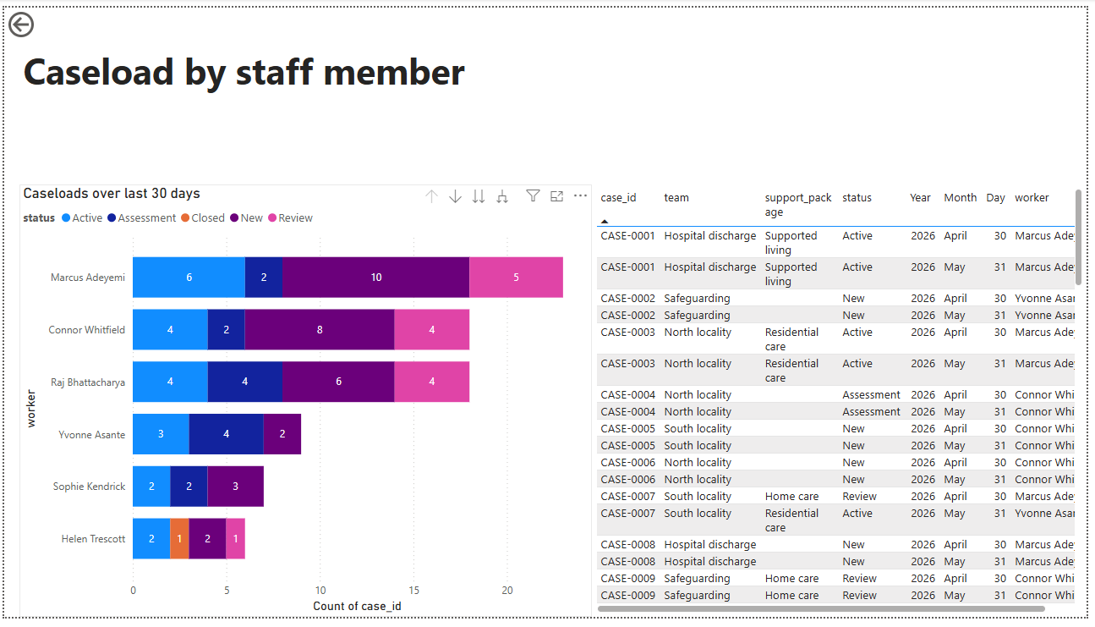
Final dashboard

Power BI report showing caseload per worker and a table tracking the escalating case (CASE-0007) across both months, demonstrating the retained history.

Build steps
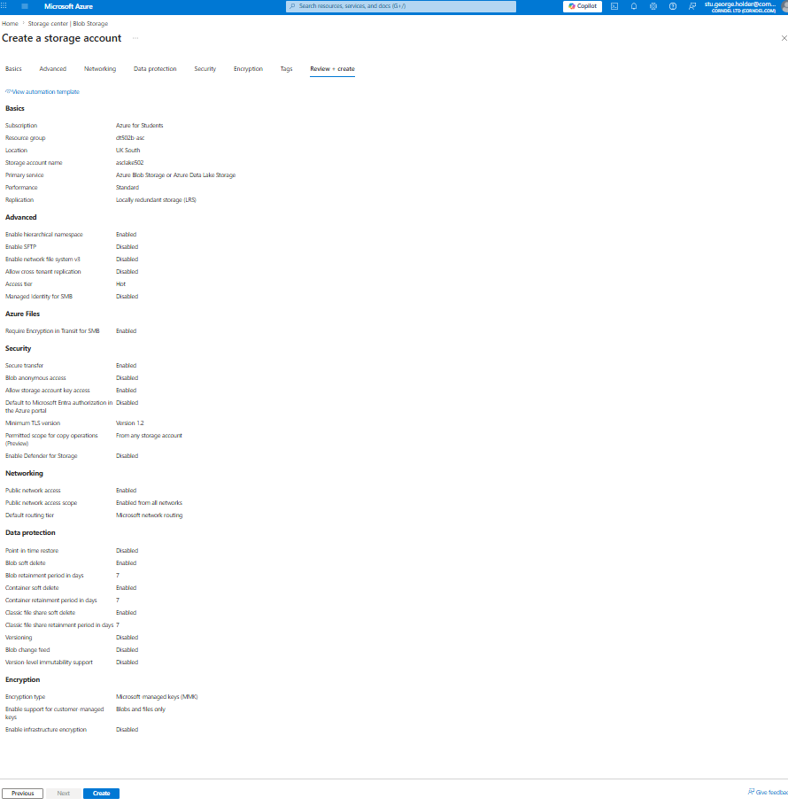
Figure 1 – Creating the Data Lake Gen2 storage account, with hierarchical namespace enabled and anonymous access disabled, providing the foundation for the raw and curated layers.
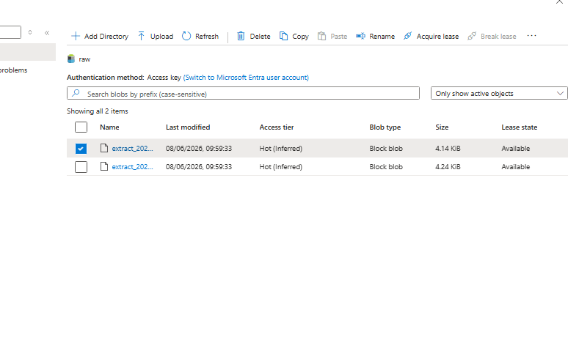
Figure 2 – The two monthly CSV extracts uploaded to the raw container, forming the bronze (raw) layer.
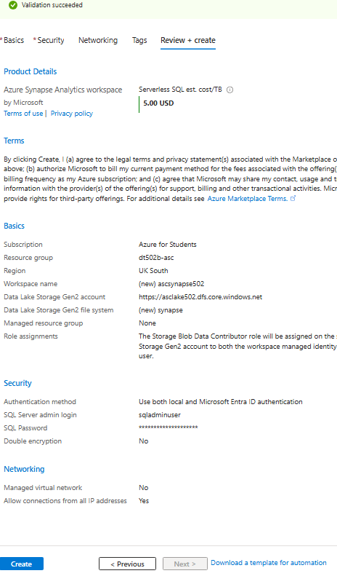
Figure 3 – The Synapse workspace configuration, the originally intended serving layer for the curated data.
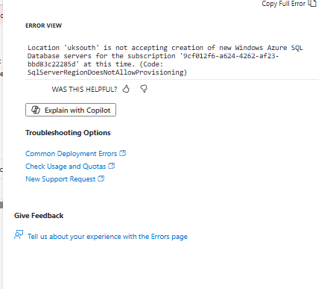
Figure 4 – The error preventing the Synapse workspace from being created, as the subscription is restricted from provisioning the required SQL server. Serving was therefore moved to Data Factory with a direct Power BI connection.
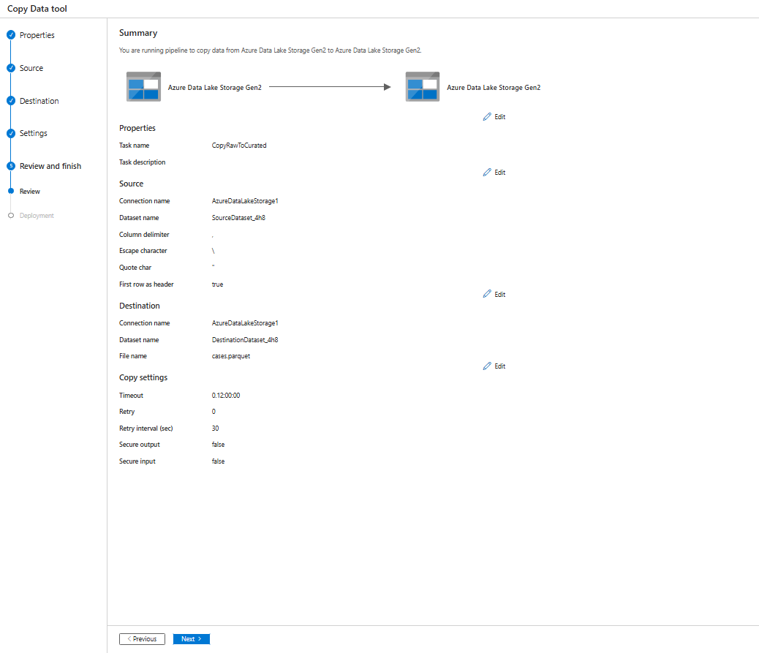
Figure 5 – The copy pipeline configured in the Copy Data tool, set to read the CSV extracts from raw and write them to the curated container as a single Parquet file.
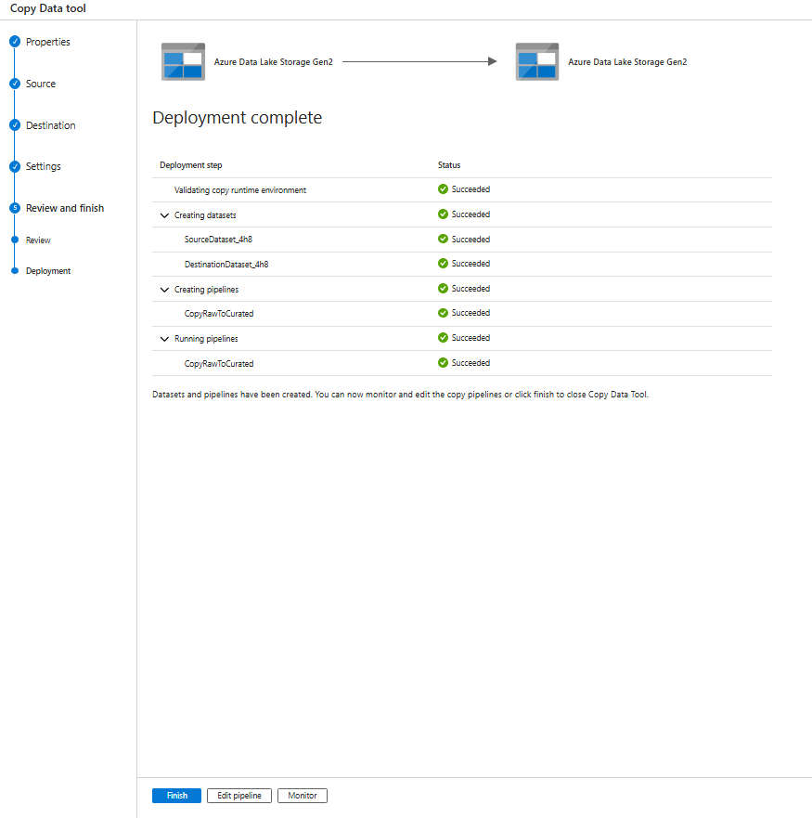
Figure 6 – The deployment summary showing all stages, including the pipeline run, completing successfully.
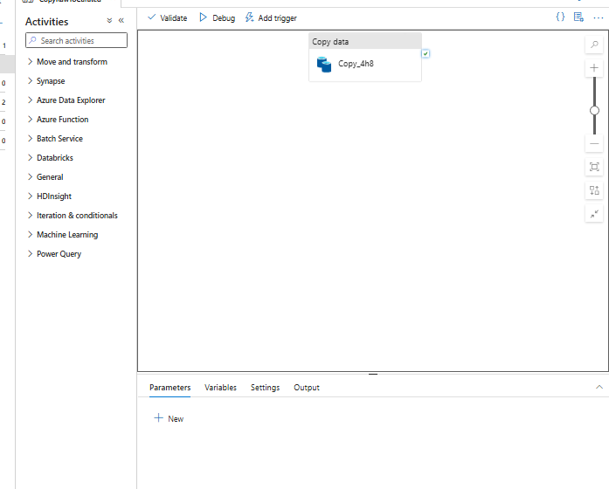
Figure 7 – The deployed pipeline in the authoring canvas.
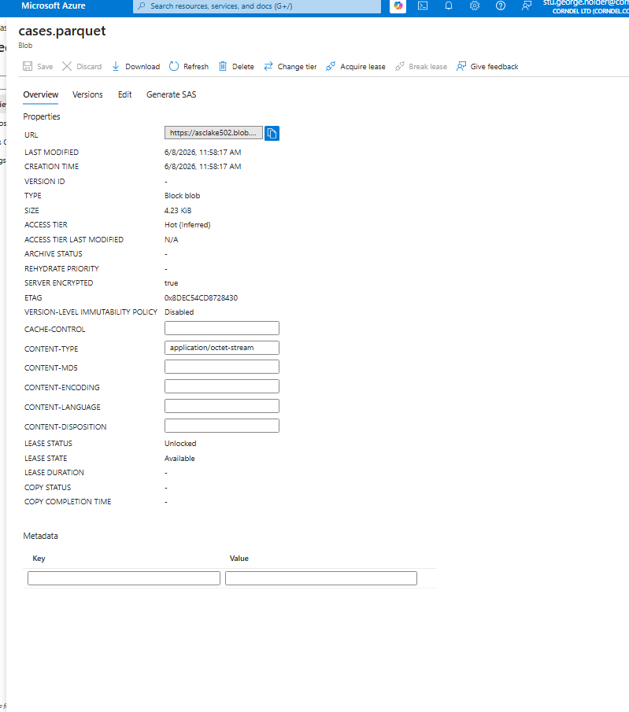
Figure 8 – The properties of the resulting Parquet file in the curated container, confirming the curated layer was populated and the data is encrypted at rest.
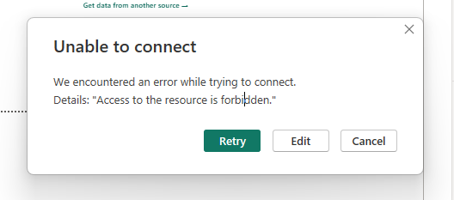
Figure 9 – The authentication error encountered when first connecting Power BI, resolved by switching to account-key access.
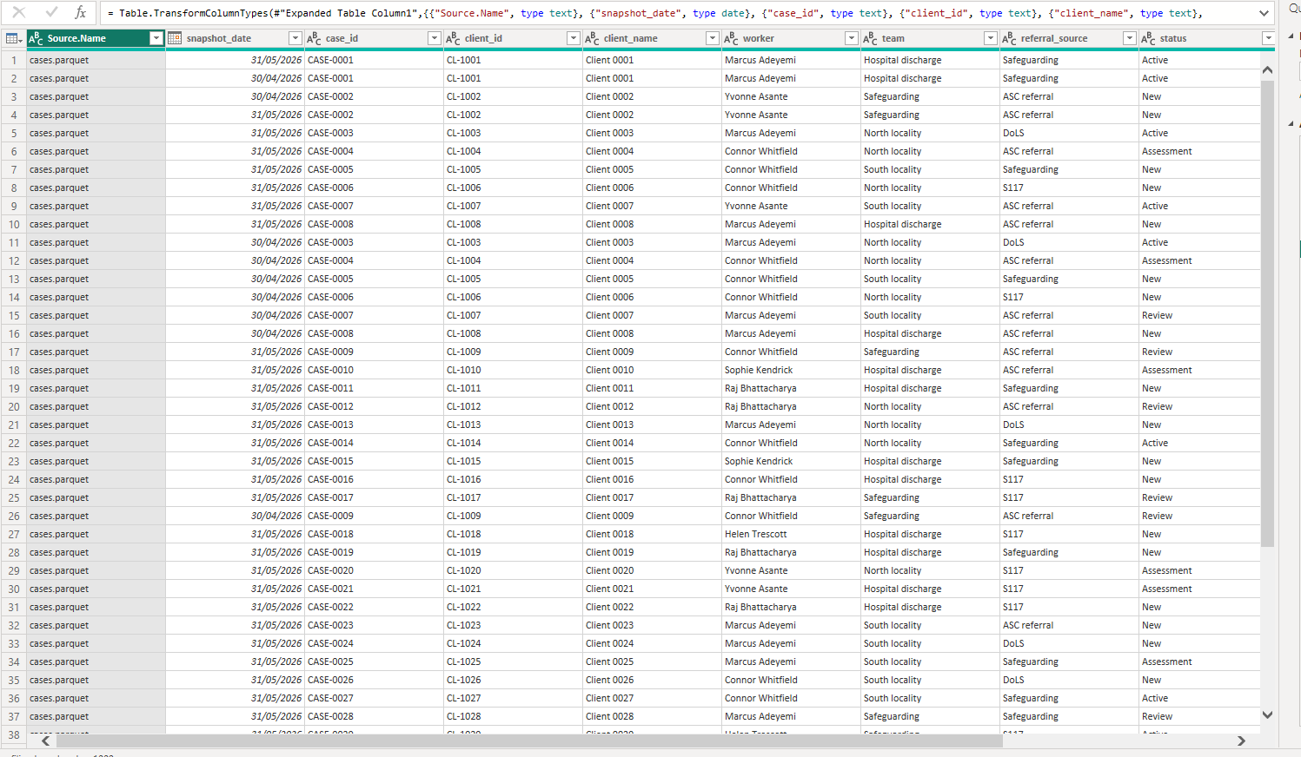
Figure 10 – The curated data loaded into Power Query, showing all columns with correct data types and both monthly snapshots present, including the same case appearing in both months.

